How to Complete the Application for
Temporary Assistance for Needy Families (TANF) – Cash Assistance

- The kinship caregiver must complete 3 sections on the Application For Benefits (FA-0001A):
- On page 1 complete the “Contact Information” section. Be sure to sign where indicated on the bottom of this page.

- On page 5 complete the “Household Information” section.
o Be sure to list all persons who are living in the home with Person #1 being the “Main Contact.”
o For the DCS placed foster child, in “relationship to main contact” column, write the child’s relationship (for example, “grandchild” or “niece/nephew” or “family friend”) AND also write “Unlicensed Foster Care.”
o In the “Applying for?” column, request “Cash Assistance” ONLY for the child who is in foster care placement with you by checking the “Cash Assistance” box for that child. Do not request any other assistance on this application as it will complicate and slow down the application approval process.
o If you do not know the Social Security number for the placed child, just leave that section blank.

- Review pages 27 through 29 and be sure to sign and date page 29.

- Return your completed application and the placed child’s Notice to Provider form (if you have it) to the child’s (children’s) DCS case manager.
- DES/FAA will call you to complete a telephone interview within 1 week of their receipt of your application OR you will receive a letter in the mail asking you to either come to a local DES office to complete the interview or call a specific telephone number to complete a telephone interview. Please do the phone interview (as wait times can be very long at DES offices).
- If you do not get a call or letter from DES/FAA 1 week after you send me your application, please contact the child’s (children’s) DCS case manager.
- When you do the phone interview with DES/FAA, if they ask you for any documentation in addition to the foster child’s DCS Notice to Provider form, please remind them that you are only applying for Cash Assistance for a DCS placed foster child in an unlicensed kinship home. If they continue to ask for additional documentation, please ask to speak with a supervisor (as it appears that your application is not being processed correctly).
- The Cash Assistance benefit does not begin UNTIL the application is approved.

Maximum Cash Assistance Amount
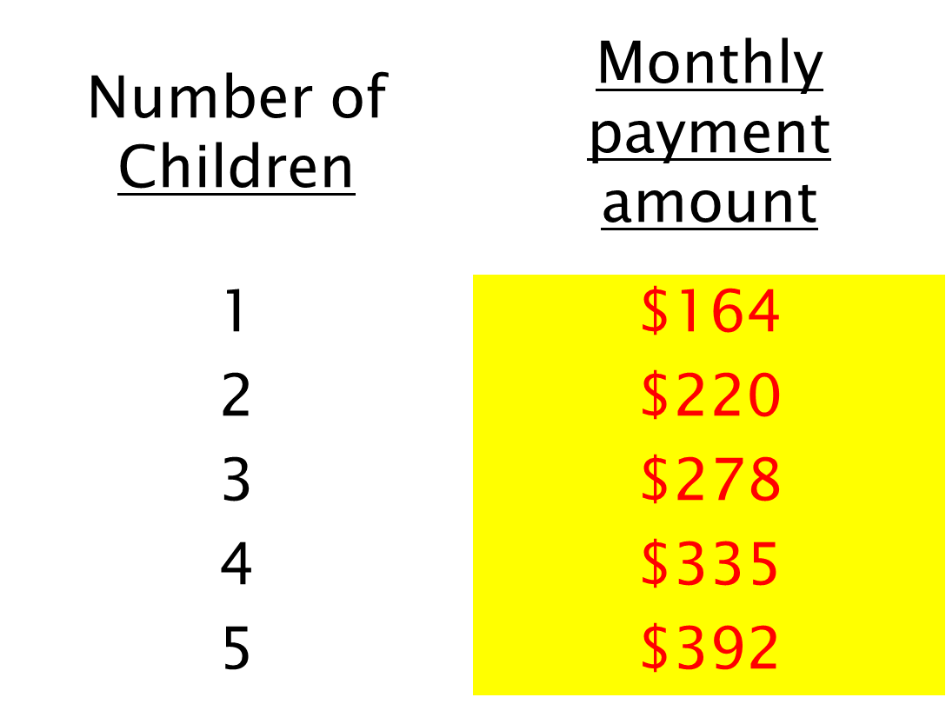

[Revised 10/12/2020]

